W E D D I N G

G U I D E L I N E S

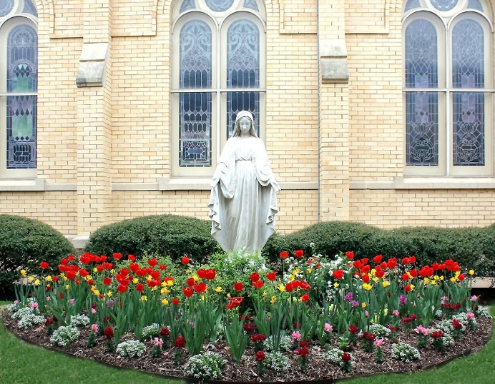

ST. MARY’S
CATHOLIC PARISH

June 2021

WEDDING GUIDELINES ST. MARY’S CATHOLIC PARISH
727 S Travis Street
Sherman Texas 75090
903 893-5148 phone 903 813-5489 fax

PREPARING FOR THE SACRAMENT OF MARRIAGE

The members of St Mary’s Parish are here to assist you and to celebrate with you the sacrament of your marriage in the Catholic Church. The seriousness of the marriage commitment is a witness to our beliefs which requires sincere and prayerful preparation.

Law of the church requires that the couple:
- be free to marry (never having been married before; free due to death of prior spouse; or declaration of invalidity of previous bond),
- has known each other at least six months,
- has adequate ability to make a mature and deliberative decision about marriage.
- has the emotional, psychological and spiritual capacities (abilities) to carry out the purposes of Christian marriage, formation of a community of life between husband and wife, the permanence of the relationship and fidelity of the partners to one another.

Couples Now Living Together

You are aware that the Catholic Church does not approve of couples living together before marriage, nor is such a living arrangement in harmony with gospel values.
We are happy to witness your marriage so that your living arrangements can be brought into harmony with God’s laws. However, we would strongly encourage you to consider living apart during this very critical time of discernment.
It is profoundly important that your choice to marry is one that is made with total freedom, and that freedom can more readily be achieved if you are living separately or, at least, living in a chaste relationship.
We know that God will bless your decision for embracing a true and honest discernment for marriage.
We recognize, however, that in today's word, it may be impractical to live separately. If you cannot do so, however, we strongly encourage you to receive the Sacrament of Reconciliation prior to your wedding.

WHAT’S REQUIRED OF THE COUPLE:

- Initial meeting with Deacon Jim Adlof seven (7) months before your intended WEDDING DATE.

- Send necessary documents to Parish Office to the attention of Deacon Jim Adlof Marriage Administrator.
  - Newly issued baptism certificate (issued seven (7) months prior to a scheduled wedding date) from the church of your baptism with church seal for each Catholic. Recent copy of baptismal certificate would normally state dates of additional sacraments.
  - Affidavits that testify to the freedom of each party to marry which are filled out and signed by a parent or someone who has known you most of your life and will attest to your freedom to marry. The Dallas Diocese requires someone who has known you since early adolescence and not just the last ten years. Parents’ signature is to be witnessed by a priest, deacon, or lay pastoral assistant and the church seal applied. You may pick up form in parish office or download form: Microsoft Word - Revised TCC English Affidavit of freedom to marry.doc (txcatholic.org)
  - Marriage license issued by any county in Texas. License must be obtained at least 72 hours before the day of marriage and the license is only valid for 90 days, so plan to obtain this near the end of your marriage preparation. (The wedding coordinator will give you more details about license requirements)

- Marriage Orientation and FOCCUS questionnaire.

- Participate in one of the following
  - Engaged Sponsor Program consists of a series of six (6) meetings held in the home of a married couple who are trained in this ministry. If you choose this program, a sponsor couple will contact you to set up your first appointment. There is no additional charge for this program.
  - Engaged Encounter Weekend is a weekend program sponsored by the Diocese of Dallas. If you choose this program, you must make your reservation through the Diocesan Office. Reservations should be made in advance because of limited space.

- Meet with Deacon Jim for Pre-Nuptial Questionnaire.

- Plan to meet with a priest or deacon who is witnessing your marriage between completion of Engaged Sponsor Program and wedding date.
  - You must contact the priest or deacon(s) directly as they maintain their personal calendars.
  - Please plan to be flexible with the scheduling of your meetings since the priests’ and deacon’s schedules are sometimes unpredictable.
  - You will spend time discussing your preparedness for the sacrament of marriage.

As you can see, there is much to do for preparation of the sacrament of marriage. Please give yourself adequate time to get each of the above completed.

SCHEDULING CHURCH OF WEDDING

We ask that you treat St. Mary’s Church and St. Anne’s Church with the respect that you would treat your own treasured home and possessions. We further require that there be no smoking, eating, illegal drugs or alcoholic beverages in the church. You are requested to adhere to the guidelines regarding the use of our churches.

Scheduling your ceremony will be done with Deacon Jim Adlof.
- The wedding will be scheduled after receiving Baptismal Certificates, Affidavits of Freedom to Marry forms and the church fee is paid. St. Mary’s Fee for Parishioner $420, Non-Parishioner $620. St. Anne’s Fee for Parishioner $920, Non-Parishioner $1120. The above fee does not include a stipend to the priest. The services of the priest or deacon are free; however, it is customary to offer a stipend. Couples may want to consider not only the time devoted to the wedding, but also the effort put into the marriage preparation process.
- Weddings are ordinarily held on Saturdays. No wedding may be scheduled on All Soul's Day (November 2nd), or the season of Advent or Lent.
- No wedding may be scheduled closer than three hours to another wedding or two hours from a regular parish liturgy.

- When certain feast days and Holy Days of Obligation fall on a Saturday, weddings may not be permitted.
- The Sanctuary and Church decor reflecting each liturgical season will remain in place for weddings.
- During the Christmas and Easter seasons, the more elaborate Sanctuary arrangements are to be left in place. You may bring your own flowers if you wish, but sanctuary flowers at these liturgical times will remain - they cannot be moved. Flowers are allowed either front or side of altar appropriate to liturgical season.

- St. Anne’s Place is available for use of bride’s and attendants dressing. Small snacks and soft drinks may be permitted in the bride’s room, but no alcohol or illegal drugs are allowed. All rooms must be cleared out immediately prior the ceremony. Reservations of rooms for dressing must be made with parish staff.

- Rehearsal is normally the night before the wedding and must be scheduled. Readers must attend rehearsal.

PLANNING THE WEDDING CEREMONY

Planning the ceremony from the environmental setting to the choices of Scripture, music, prayers, and additional ritual should be done as carefully as possible because the wedding ceremony will announce to all who attend how the couple understands their relationship with each other, with God and with God's people.

The staff, the priest or deacon, music director and wedding coordinator are prepared to assist you in your discussions, reflections, and choices for the best expressions of your love and faith. We would like to help you construct a full ritual that is both reverent and truly beautiful. The overall ritual structure is given to us by the Universal Church, but some pastoral options are available. Music is provided by St. Mary’s and is coordinated via the Director of Music. Please contact Director of Music for their fees. If outside musicians are requested, it must be approved by the St. Mary’s Director of Music and a fee for coordination occurs. Music must be approved two weeks in advance. If you plan to decorate the church, you are required to coordinate with wedding coordinator.

DIRECTOR OF MUSIC

English- Claire Dering (903) 487-8029
Spanish- Erika Reyes - Email address: erikareyes577@yahoo.com

WEDDING COORDINATOR

English- Dawn Laxson (903) 814-1026 or Susan Vogel (903) 821-2570
Spanish- Monica Reynoso (903) 870-2074

DRESS CODE- all members of the wedding party must be modestly dressed (appropriately).
- NO mini skirts
- NO cleavage showing

PHOTOGRAPHERS are usually an integral part of your wedding day.
- They may arrive one hour before the ceremony and take pictures in the church up to 30 minutes before the scheduled wedding time.
- After the ceremony, only 30 minutes of photography is allowed.
- Flash photographs may be taken only during the processional and recessional.
- No flash pictures may be taken during the ceremony; a photographer must use natural lighting only, so as not to disrupt the sacredness of the ceremony.
- Photographers are not allowed in the altar area during the ceremony or within view of the people or in center aisle.
- Please inform family and close friends that flashing cameras are not appropriate during the liturgy.
- Photographers are not allowed to move the church furniture, (i.e. altar, ambo, candles) If any chairs are moved, the photographer is responsible for putting them back in their original position.
Photographers must check in with the wedding coordinator when they arrive and go over the church’s placement for pictures and other questions they may have.

VIDEO TAPING- is permitted from discreet locations in the church.
- Videographers may arrive one (1) hour before the ceremony to set-up.
- Videographers should avoid being a distraction from the holy occasion.
- They may not enter the altar area, but they may set up on either side of the church sanctuary without going up the steps or at the back of the church.
- Setting a tripod and staying in one location is recommended.
Anyone who will be videotaping must check in with the wedding coordinator upon arrival at the church and she can assist them in proper set-up locations.

PRINTED WORSHIP AIDS are very appropriate for a wedding liturgy and encourage congregational singing and response. These can be easily prepared and are thoughtful gestures inviting the community present to participate in the celebration. These need to be approved by the Marriage Administrator or Coordinator and approved two weeks in advance.

Out of safety concerns, there will be no flower petal droppings, no rice, no confetti, no bubbles on church property.

Any questions you may have regarding the environment of the church on the day of the wedding ceremony should be directed to the wedding coordinator.

